**Name – Parag Gattani**

Program No. – 05

Program Title – ON/OFF LED using Push Button

**AIM**

Demonstrate to show ON/OFF of a LED using push button(Digital Output).

**HARDWARES REQUIRED**

* Arduino Board
* LED bulb
* Push Button
* Resistor

**CIRCUIT DIAGRAM**

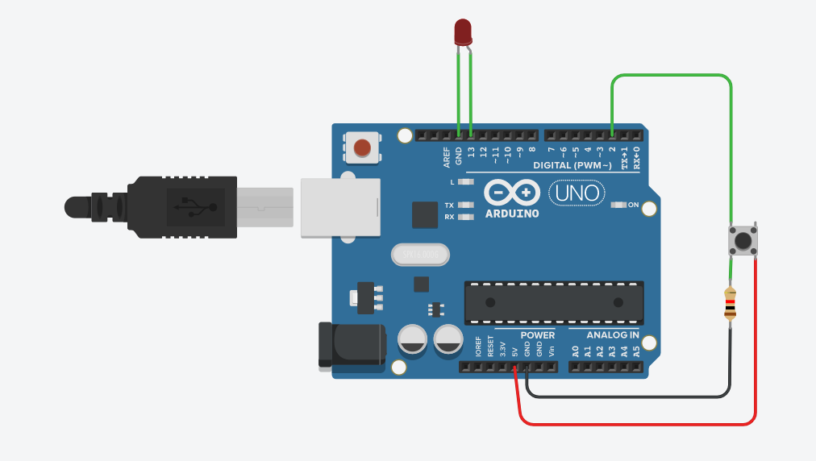

**WRITE-UP**

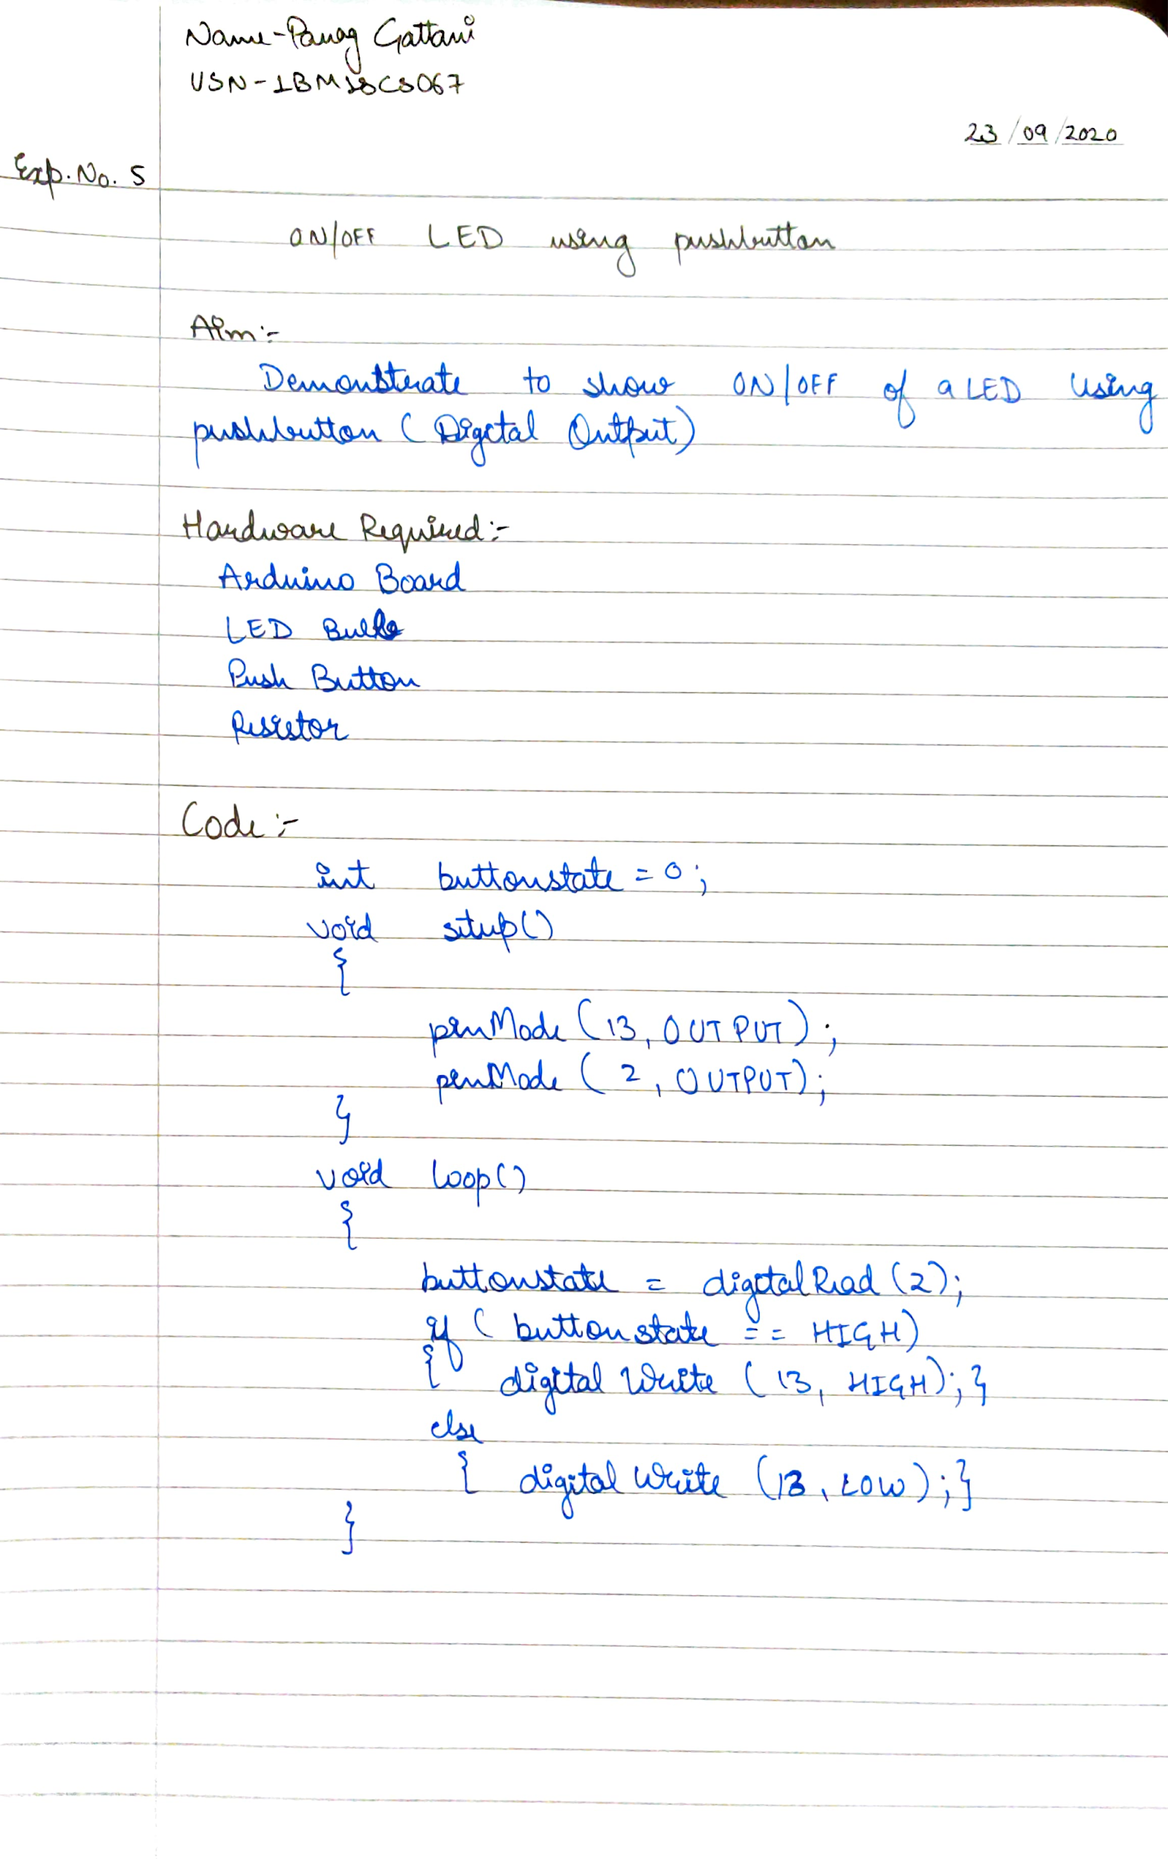

**CODE**

int buttonstate=0;

void setup()

{

pinMode(13, OUTPUT);

pinMode(2, OUTPUT);

}

void loop()

{

buttonstate=digitalRead(2);

if(buttonstate == HIGH)

{digitalWrite(13,HIGH);}

else

{digitalWrite(13,LOW);}

}

**OUTPUT**

ON/OFF of a LED using push button(Digital Output).